Communication is very important!
Please call, text, or email if you have questions or concerns. Thanks!
tpickrel@fullerton.esu7.org
my number 308-550-0081
school 308-536-2431
We will celebrate birthdays in the classroom. If they have a summer birthday, we will celebrate it at their half birthday.
(June 9 would celebrate on December 9.)
You may bring treats for the class if you’d like. We have 21 students.

I will be taking pictures of the students throughout the year. These will be used in our class books, newsletters, our school website, and bulletin boards.

--WATER BOTTLES—
Please bring a water bottle from home. This cuts down time at the water fountain.

Breakfast is 7:30-8:00 AM.

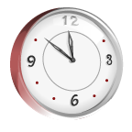
Our day is 8:15-3:15. Students will be considered tardy after 8:15. If your child is tardy or comes at a different time, they will have to push the call button by the main doors to be allowed in. Then they need to check in at the office.

Flip flops are not recommended for school.

We will have a milk break in the afternoon. Students may bring a snack. Milk will be paid by semester.
No candy please.

Music and PE schedule:
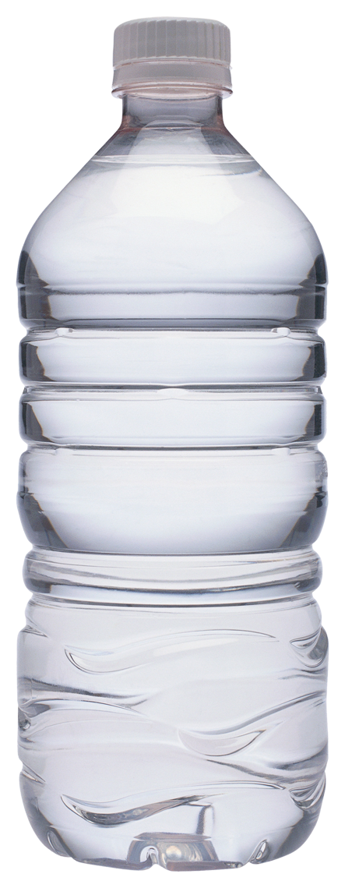
Monday: PE
Tuesday: music
Wednesday: PE
Thursday: music
Friday: odd # days-music
Even # days-PE

Please wear tennis shoes on PE days.

